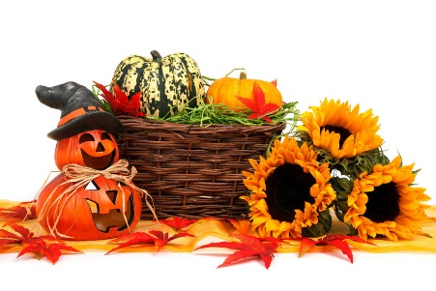
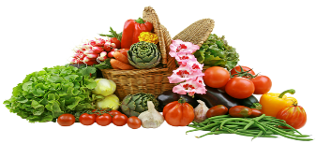
ILLINOIS STATE GRANGE AGRICULTURAL CONTESTS
This Photo by Unknown Author is licensed under CC BY-NC
GRANGE YEAR: 2022 – 2023

Joan Fidder, Chair Steven Kinzinger Brian O’Dell
Flora Grange Progressive Grange Beaver Valley Grange
723 E 4th St, Belvidere, IL 61008 618-972-8436 815-670-1272
815-505-2269
(Please text or leave message)

VEGETABLES
Green Beans (5)
Wax/Yellow Beans (5)
Beets (3)
Cabbage (1 head)
Cucumbers (3)
Eggplant (1)
Gourds (3)
White Onions (3)
Yellow Onions (3)
Sweet Peppers (3)
Hot Peppers (3)
Red Potatoes (3)
White Potatoes (3)
Carrots (3)
Sweet Corn (3 ears)
Cherry Tomatoes (5)
Red Tomatoes (3)
Yellow Tomatoes (3)
Winter Squash (1)
Yellow Summer Squash (1)
Zucchini 6-8” (1)
Largest Zucchini
Most Unusual Vegetable

FRUITS
Apples-Any Color (3)
Cantaloupe/Muskmelon (1)
Grapes (3 bunches)
Pears (3)
Pumpkin (1)
Watermelon (1)
HERBS
Potted specimen of an Herb, must be named
Collection of Herbs,
4 or more, named

FIELD CROPS
3 Ears of Corn
Longest Ear of Corn
3 Ears of Indian Corn,
Husked
3 Ears of Popcorn
Corn (1 quart bag)
Oats (1 quart bag)
Soybeans (1 quart bag)
Wheat (1 quart bag)
Sunflower Head (1)

FLOWERS
Make It Yourself:
Roadside Bouquet
(Flowers, etc, provided)
Flower Garden Bouquet
Zinnias (3 stems)
Marigolds (3 stems)
Cosmos (3 stems)

MARKET BASKETS
No Larger than 30”
(8 or more items)

Individual Basket
Group Basket
ANTIQUES
Written Explanation of item:

Farm related
Household related

VALUE ADDED PRODUCT
8 oz jar of any Jam, Jelly,
or fruit butters
Jar of Pickles
(Must label what type)
8 oz of Honey
Jar of Salsa

DIAMOND ART
Adults & Juniors: Any item pertaining to the farm (animals, barn, tractor, etc)

JUNIORS
Decorated Pumpkin
(No carving)
Any Vegetable
Farm Safety Poster

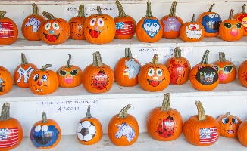
NOTE:
- One entry per person per category
- All products must be grown/made within current Grange year

